**Total Weight/Mark: 10points**

**Time: 60minutes + 15minutes = 75minutes**

**Lab Test Question:**

1. Take a file named “code.txt” with the following lines (I will provide):

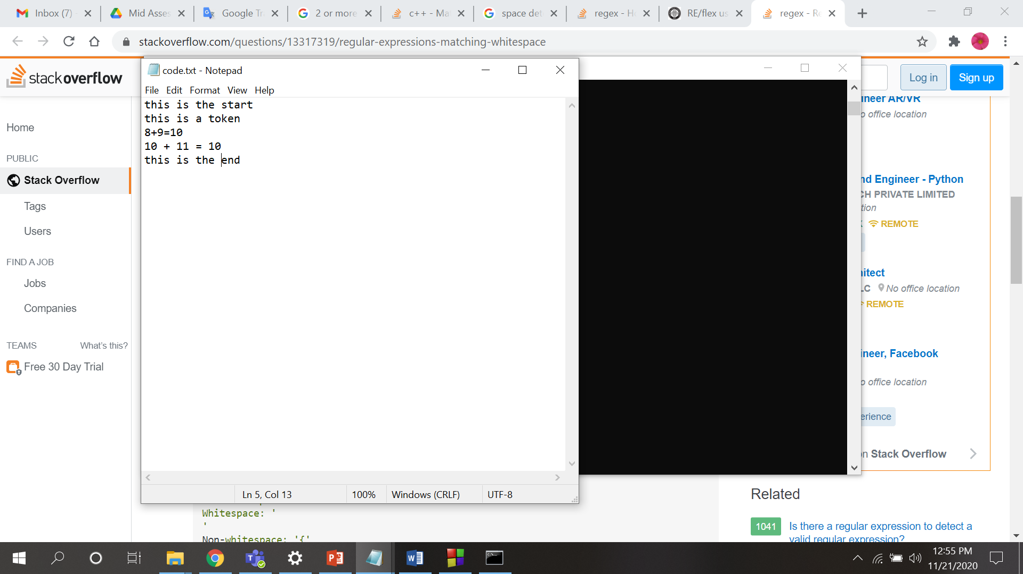

1. Write **one** c or cpp program to count and show the alphabetic **words only that starts with ‘t’** and will **count the total line number**. After executing the program the output will be like the following: [weight: 8points]

**Sample output:**

**The file content is as follows:**

**this is the start**

**this is a token**

**8+9=10**

**10 + 11 = 10**

**this is the end**

**Our output:**

**Number of total words: 12**

**Number of words starts with ‘t’: 6**

**this,the,this,token,this,the**

**Total line: 5**

1. **First read the file ‘code.txt’ and print the content [2]**
2. **Then find and count the alphabet words and show and count those words that starts with ‘t’ (e.g. this, the etc) [3]**
3. **Count the new lines [2]**
4. **Print the above output [1]**
5. Rename the c or cpp file into “yourID.c/cpp” and upload code file (c or cpp) with screenshot of the output or error screen (**don’t crop**);

which means we need to upload two files. (i) c/cpp file (ii) .jpg/ .png file (image file) and do not forget to turn in.

Please follow the instructions. Otherwise we will loose point. [Weight: 2points]